Diamond-S Ditch Fish and Boat Passage:
Proposal

Completed For:
Dr. Joshua Hewes, Dr. Wilbert Odem
CENE 476- Capstone Lab
Northern Arizona University

Completed By:
Thaddeus Bahl, Burnell Jones, Jordan Udall

Submitted On:
Wednesday, December 05, 2012

1.0 Project Understanding 3
1.1 Existing Conditions 3
1.2 Purpose of the Project 3
1.3 Background 4
1.4 Key Stakeholders 5
1.5 Technical Needs for the Project 6
1.6 Potential Challenges 6
1.7 Factors of a Successful Project 7
1.8 Timeline 7
2.0 Scope of Services 8
2.1 Project Management 8
2.2 Survey 9
2.3 Geotechnical Analysis 9
2.4 Research 10
2.5 Hydraulic Analysis 10
2.6 Project Alternatives 12
2.7 Permitting 12
2.8 Final Design 13

Figure 1 3
Figure 2 4
Figure 3 4

Project Understanding
  - Existing Conditions

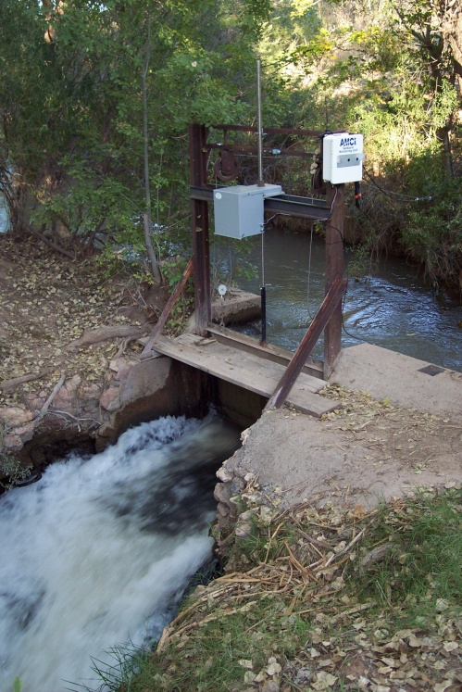
Approximately one half of a mile north of the Highway 260 Bridge crossing the Verde River in Camp Verde is a diversion structure for the Diamond-S Ditch. This structure completely diverts the flow in the Verde River channel to the ditch. The diverted flow varies throughout the year from 50 cubic feet per second [cfs] to 100 cfs. An electronically controlled sluice gate (Figure 1) just north of the bridge is used to maintain a constant flow of approximately 30 cfs in the Diamond-S ditch while the remaining smaller portion of the flow is diverted back to the river channel. Three gauges in the ditch monitor the level and flow of water. One of the gauges monitors the flow downstream of the sluice gate. If the flow varies from 30 cfs, the gauge signals the automatic sluice gate to increase or decrease the water being removed from the ditch.
Figure 1

  - Purpose of the Project

    - Fish Passage:
At the sluice gate, the water diverted from the ditch back to the river channel makes a sudden elevation drop of approximately five to six feet. The small orifice created by the sluice gate and the relatively high flow coming through create high velocities in the diversion flow. The combination of elevation change and high flow velocity create a barrier for even the strongest swimming fish in the river. This barrier prevents fish in the lower part of the Verde River from traveling back up the river when environment conditions in the lower part are less optimal. The goal for this part of the project is to eliminate the barrier by providing a way for the fish to get back into the ditch from the Verde.

    - Option to Shut Off the Ditch:
The design of the sluice gate is to divert a portion of the water through an orifice in the side of the Diamond-S ditch back to the River. If it were fully open, the water would be split between the ditch and the Verde River. The goal for this part of the project is to provide an option to divert all the water from the ditch during times when there is no irrigation demand.

    - Boat Diversion:
The diversion to the ditch and subsequent structures in the ditch also create a social recreation problem. The Verde River is a popular recreation area. Some of the more popular activities are to kayak, canoe or raft the Verde. At the initial diversion to the Diamond-S ditch, the boaters must use the ditch to continue or they will have to carry their boats for several hundred feet. After being diverted to the ditch, a boater would soon come to an impassible culvert. So even if they decided to use the ditch to continue, they would have to pull out of the ditch on its steeply engineered banks at this point and carry their boats to the river. The goal for this part of the project is to provide passage for these small recreation boats from the ditch to the river below.
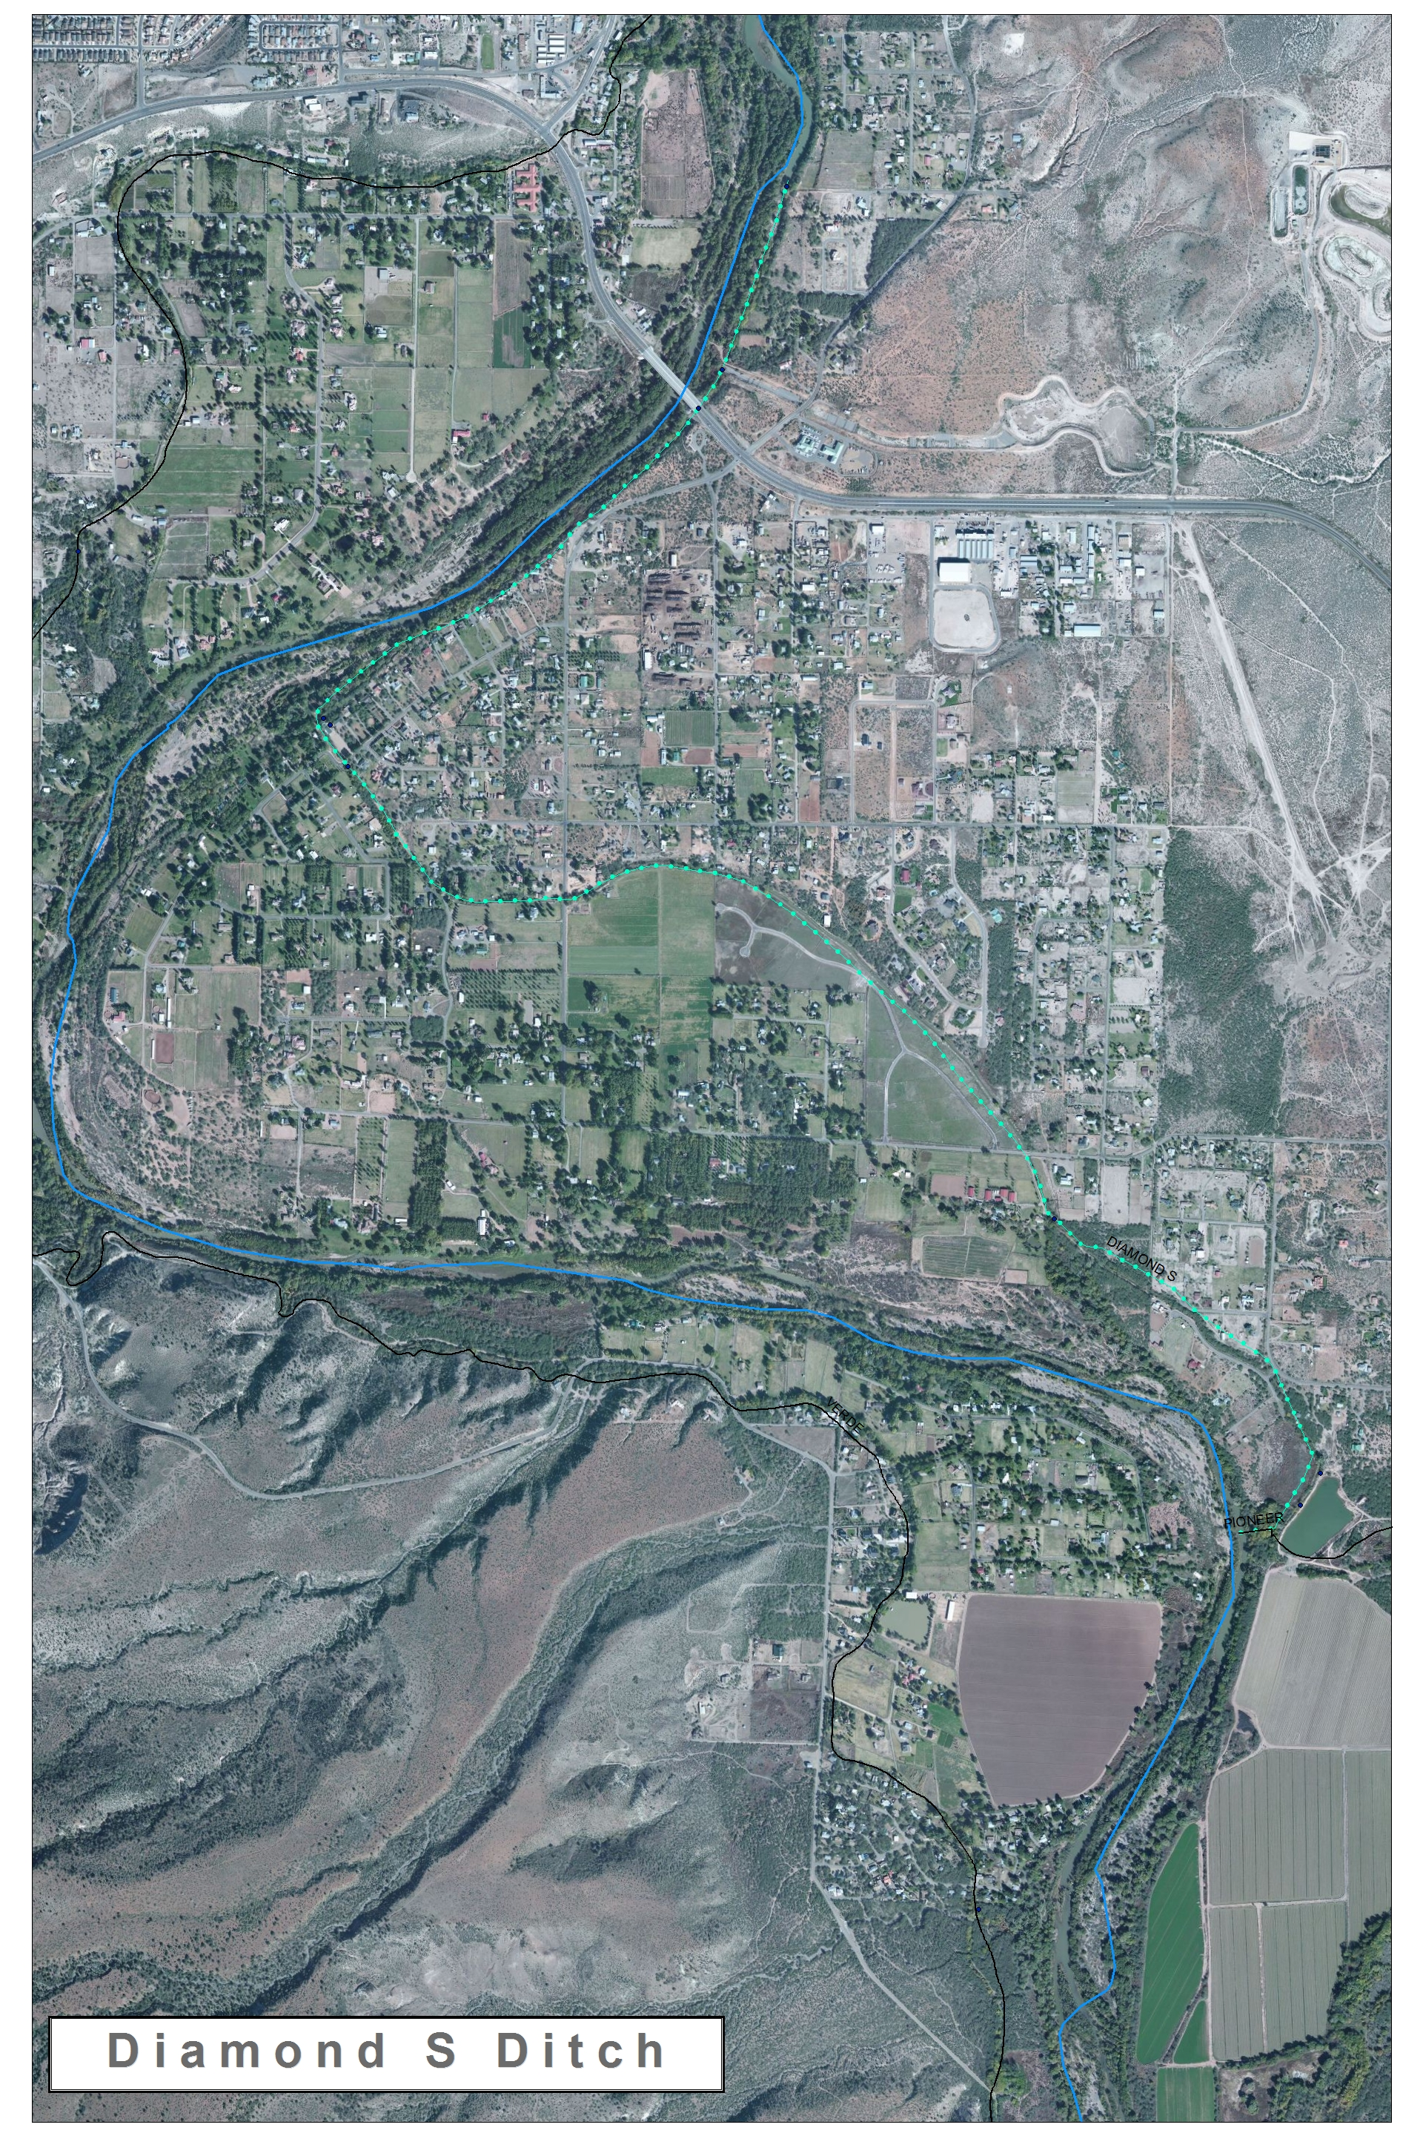
Figure 2

  - Background

The Diamond-S ditch was built along the Verde River in the 1870s. The Diamond-S ditch is located in Camp Verde with the furthest downstream primary point of diversion of the seven large ditch companies in the Verde Valley. They have made many efforts to be as efficient as possible, have a strong board and are interested in new technology. The county has no restrictions on the quantity of water which can be removed at any point throughout the year. This lack of restriction can lead to excess water being removed from the river compared to the actual demand for irrigation.
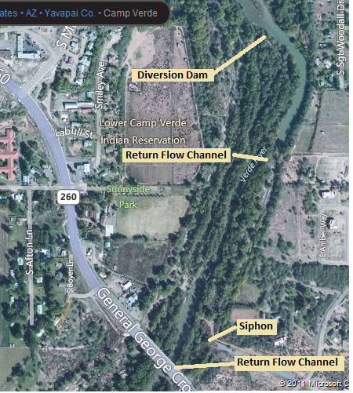
Figure 3

The Diamond-S ditch can be viewed in Figures 2 and 3. Figure 2 shows the ditch as a whole. Figure 3 shows the area of the ditch which will be of greater concern for the project. The ditch facilitates nearly 60 users who are mostly small agricultural users and one 200 acre pecan orchard. Each farm served by the Diamond-S ditch has a well providing drinking water.
The current diversion structure on the ditch is designed to take the entire flow from the river into the ditch then excess water is returned to the river within half a mile. This process of removing excess water causes a barrier and native fish species become isolated. The native fish species of concern includes several endangered species such as the razorback sucker, roundtail chub, and northern pike minnow.
The Nature Conservancy has initiated water efficiency projects with several ditch companies over the past year in order to achieve flow restoration objectives in the Verde Valley. Flow restoration can be achieved through a variety of project activities such as infrastructure improvements, water delivery management, reduction in consumptive use or changes to the timing and method of delivery.

  - Key Stakeholders

Stakeholder | Involvement
Kimberly Schonek | Kimberly Schonek is an environmental scientist working for the past four years on reducing the environmental impacts caused by the ditch system surrounding the Verde River, while maintaining quality service to the shareholders
Diamond-S ditch Board of Directors | - Richard Tinlin, President  - Steve Goettig: Vice President  - Frank Geminder, Secretary  - L. Richard Mabery, Statutory Agent  The business and affairs of the corporation are managed by its Board of Directors in all matters except those reserved for the vote of the membership. A majority of the Board is required to take actions affecting the operation of the Ditch, in particular to authorize expenditures exceeding $250.00, and to authorize replacement, removal or installations of headgates, power easements, culverts, pipelines, bridges, or other major components of the ditch.
Ditch Shareholders | The Diamond-S ditch is a shareholder owned ditch. The shareholders have an interest in protecting their water rights to the Verde River. Most of the shareholders have farms in the area; however, they do not rely on income provided by these farms. The shareholders have recently gone through a policy change and are interested in reducing the impacts of their ditch on the ecosystem.
Coca-Cola Company | The Coca-Cola company provided funding for the current control structure and has expressed an interest in funding further ecological restoration.

  - Technical Needs for the Project

    - Hydraulic Analysis
One of the initial tasks of the project will be using open channel flow analysis to determine how to create the flows, depths, and velocities necessary to facilitate the passage of both fish and small recreational river boats.

    - Geotechnical Analysis
Alternative designs for the passage facility will either require water to pass over the existing soil in a ditch or for the existing soil to provide a foundation for an engineered facility whether it is a concrete structure or a reinforced soil lining for a channel. Geotechnical analysis will be required to determine the ability of the existing soil to perform in any of these capacities.

    - Surveying
Some data is available and will be used for the local topography of the area. However, further surveying will be required to determine precise elevations of existing facilities and to design new facilities.

    - Research
Research has been done and data has been collected for many of the hydraulic properties of the Verde River. This information will need to be acquired. In addition to this information, research will be done on facilities in other places designed to solve similar problems and standards already in place. Some ichtheological research will be required to determine what flow conditions will permit passage for local fish. Further research will be required to determine what flow conditions will be required to facilitate small recreational boat passage.

  - Potential Challenges

One potential challenge which could be encountered during this project is a conflict between constructing the new control device and continuing the flow at a high enough rate to meet the demand. The issue could be resolved by constructing the structure during a period when the fields would not require irrigation. A second potential challenge is construction costs. The possibility to include a canal large enough to accommodate canoes or kayaks would require earth removal and would increase the cost of the project. The control structure, which our group is designing, must be able to operate at low flow as well as high flow. The ability to operate at low flow will have important implications in the design of our structure and may eliminate the possibility to accommodate recreational river traffic. The environmentalist who is working on the ditch is attempting to convince the ditch managers to decrease the amount of water being drawn from the river; this could severely reduce the flow available for the fish ladder to work.
  - Factors of a Successful Project

Key factors for the success of the project will be a design that successfully provides fish passage and boat passage with the available flow and topography. A further factor of a successful project will be one that can be constructed easily and within the monetary amount Coca-Cola is willing to provide. A successful project will be one that can be used as a guide for other similar places on the Verde River in Camp Verde’s irrigation ditch system. To complete the project, there will have to be a good, helpful and beneficial communication between the designers and the client. Along with good communication there will have to be a mutual understanding of the deliverable for the project. A sound understanding of what is being asked for will greatly improve the success of the project. Finally, there will have to be accurate data and information because without these there will be no success of the project. The more accurate the data and information the better the design will be. The accurate data and information will ensure the client receives what they are looking for and they are satisfied.

  - Timeline

The timeline for the design portion of the project will be from January to May 2013. The project design will be used as a standard for future projects and does not have an implementation deadline. The construction of the project would take place during the time period of the year which has the least amount of demand on Diamond-S canal. Construction of the project could start at the Verde River bed and finally be connected to the ditch during the month of lowest demand. Following a construction plan like this would minimize the effect on the ditch shareholders.

Scope of Services

Several tasks are required to design a facility that allows upstream passage of fish and downstream passage of small recreational boats between the upper Diamond-S Ditch and the nearby Verde River. The tasks needed for this project can be divided up into eight categories, listed below.

- Project Management
- Surveying
- Geotechnical Analysis
- Research
- Hydraulic Analysis
- Permitting
- Design Alternatives
- Final Design

  - Project Management

    - Project Development Meetings
Project development meetings will be held to review the status of the project and identify and resolve project issues. These meeting will be attended by the design team, the client, and the project technical advisor. The design team will provide a meeting notice and agenda to those attending.

Deliverable: Meeting notice
Meeting agenda
Meeting minutes

    - Quality Control
A quality control plan will be provided to ensure calculations and design considerations have been checked by the project technical advisor and NAU staff prior to the final submittal.

Deliverable: QC plan

    - Communication
Communication will be a chief priority in the engineering design. First, the team will communicate by no less than one weekly team meeting to develop weekly work plans and review work done in the prior week. Second the team will meet frequently with the project technical advisor so he can review progression on the project, respond to design inquiries, and identify project issues. Third, the team will maintain communication with the client through the project development meetings and through email and telephone in order provide project updates and respond to inquiries.
Deliverable: Weekly work plan

  - Survey

Geometric conditions of the fish and boat passage facility, like slope and available land area, will be the primary determining factors of how the existing flow can be manipulated to provide desirable velocities, depths and widths of the passage channel. In order to design the slope of the facility, the actual elevations of the available land will be required. We will survey the design site in order to determine pertinent elevations and topography.

Deliverable: AutoCAD Basemap

  - Geotechnical Analysis

All design alternatives will require analysis of the existing soil conditions in the area between the diamond-S ditch and the Verde River bank. Geotechnical analysis will determine if the existing soil will be suitable as a:

-Channel lining (as is)
-Channel lining (if compacted or otherwise modified)
-Foundation for concrete structure
-Foundation for other channel lining such as riprap

    - Sieve Analysis
We will provide a sieve analysis of the soil at the design site. From this sieve analysis we will classify the soil and determine its hydraulic conductivity. The hydraulic conductivity of the existing soil will be used to determine how much of the water in the passage facility would be lost to infiltration if it is not lined with some other impermeable layer.

Removal of excavated soil can be expensive. Some soils have qualities that can be used for construction of some other facility. Rather than just wasting the soil, it may be sold, depending on its classification from the sieve analysis.

    - Analysis of Unit Weight, Swell, and Subsurface Conditions
We will perform a sand cone test on soil at the design site to determine the soil’s unit weight and how much it will swell when excavated. Knowing the unit weight of the soil and how much it will swell will be helpful in estimating how much soil will need to be removed from the site, thus determining the cost of removal. We will also excavate a sample of the soil to evaluation the subsurface conditions at the design site. Evaluation of the subsurface will be used to determine what kind of equipment will be necessary to excavate the soil.

Deliverables: Sieve analysis data
Geotechnical report
Bed Channel Scour Report

  - Research

    - Similar Facilities
An analysis will be performed of literature pertaining to fish/boat bypasses, designs of similar facilities, and other hydraulic structures along the Verde River. The analysis will require field research as well as general research.

    - Standards
This project will be constructed in Camp Verde, Arizona on U.S. Forest Service Land. Camp Verde, Arizona and the forest service will have standards for general construction and one or all of them may have specific standards for fish passages. We will research these standards to ensure the construction compliance.

Deliverable: Field Research Minutes
Report of pertinent information

  - Hydraulic Analysis

    - Average Flow Analysis
Much of the fish and boat passage design will be determined by the flows at the intake of the Diamond-S Ditch. Some of the information for annual and seasonal flows in the Verde River and the irrigation system already exists. We will locate this information and utilize it to determine the average yearly flow in the ditch and the average flow for each month.

We will use average monthly flow information to determine what months, if any, will produce a flow that will accommodate the requirements of fish passage and boat passage.

Deliverable: Flow analysis report

    - Open Channel Flow Analysis
Different fish species can overcome different flow velocities in a stream. Additional criteria for fish passage will be the depth required specifically for native Verde River fish to swim. Research regarding what velocities and depths are required for native fish in the Verde River will be obtained through collaboration with either the NAU biology department or The Nature Conservancy. We will use the results of this ichthyologic research to design a channel with a velocity and depth that will accommodate native fish passage. Velocity and depth of flow in the passage can be manipulated by making adjustments to its roughness, slope, and width.

The largest constraint for recreational boat passage will be the depth and width of a channel required to accommodate the dimensions of a typical boat found in this stretch of the Verde River. Three scenarios for boat passage will be considered in a design depending on available flow. They are listed below in order of design preference:

- Depths of flow allow a boater to ride through the passage facility in the boat
- Depths allow the boat to pass but the boater must get out of the boat and guide it through the facility.
- Available flow does not allow for depths and widths required for an unoccupied boat to float through the facility and the boat must be removed from the channel and dragged to the river.

We will determine if decreasing the slope and increasing the roughness of the channel will increase the depth and width of the channel enough to accommodate the typical recreational boat in that stretch of the Verde River.

Deliverables: Analysis of reports received from Ichthyological research group
Open channel flow analysis report

    - Analysis of Historic Storm Events and Watershed
The design for the facility will be mostly determined by the minimum available flows in the channel. However, analysis of the maximum flow the facility will be required to endure will be important in the design of a channel resistant to erosion by potential floods and high velocities. We will estimate the potential record flows by delineating the size of the watershed that drains into the Verde River at the point of the facility and combining it with a historical record storm event obtained from the National Oceanic and Atmospheric Administration’s Hydrometeorological Design Studies Center.

Deliverables: Map showing delineated watershed
Analysis of estimated potential flooding

    - Orifice Flow Analysis
A design alternative would be to move the existing sluice gate into the ditch to control flow and periodically close off the flow into the ditch when there is no irrigation demand. When lower irrigation demand targets are met, a gate in the ditch would allow reduction of flow into the ditch and increase flow to the fish and boat passage facility. We would provide orifice flow analysis of the gate. This analysis will include resulting depths of the irrigation ditch.

Deliverable: Orifice flow analysis report

  - Project Alternatives

We will provide three design alternatives that meet the following constraints:

-Maintain 30 cfs in the Diamond S ditch
-Provide passage from the Verde River’s natural channel to the Ditch for native fish
-Provide passage for small recreational river boats like canoes
-Provide a means to send all of the water into the natural channel from the ditch when there is --no irrigation demand
-Be resilient to a 25 year storm event
-Be self-cleaning
-Mitigate the possibility of physical injury to humans
We will present a 60% complete design for each alternative to the client and stakeholders for selection of the final design.

Deliverable: 60% design report

    - Geometric Design
We will provide a proposed map with a plan and profile drawing of each alternative and including typical cross section details and earth work estimates.

Deliverable: Plan and profile drawings with details and estimates for each design alternative

    - Cost estimation
A preliminary cost estimation will be provided for each design alternative. The cost estimation will include cost of construction, materials, and design.

Deliverable: Cost estimate report for each design alternative

  - Permitting

We will research what permits will be required for construction by the City, State and U.S. governments. However, acquisition of required permits will not be within the scope of services of this design. The reason for this is, if the facility is constructed, construction will not likely start until long after the designing engineering students are graduated and unavailable for permitting.

Deliverable: Report of required standards and permits

  - Final Design

Upon completion of tests and analyses and selection of one of the alternative designs, we will create a final design that will meet all requirements while being as economical as possible. Upon approval of the final design the final design report will be completed along with design drawings. Using the survey and the geotechnical analysis, the final report will detail the earthwork removal and compaction necessary to excavate the foundation for the ditch diversion. The report will show how research of existing designs has influenced the final project design. The report will describe how the ditch diversion will function during periods high and low of flow. Included in the final design report, will be a description of the permits required for the project and the process of applying for the permits. The final design will be presented to the client and shareholders at a meeting in May 2013.

Deliverables: Final design report
Design drawings
Design poster display

